Conversion of KM and MILE in lead-acid instrument
- Press the black button on the instructment, open the electric lock at the same time, the instrument will show KM or MILE in the red place of instructment.
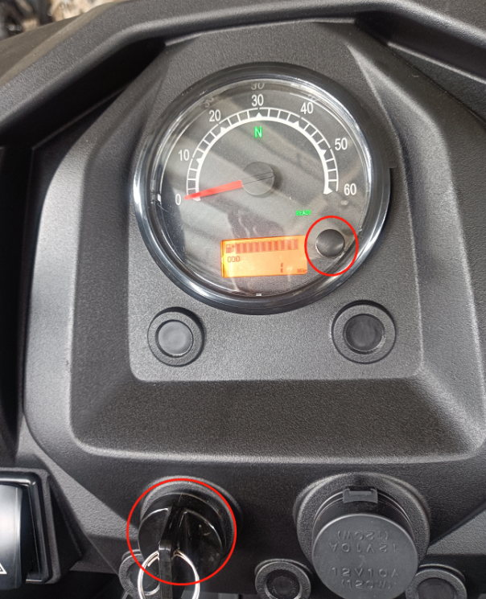
- Press black button, change KM/MILE, choose KM or Mile based on your need, then turn off electric lock. Turn on the electric lock after 10s, the instructment will show the selected unit.
